**Updated 7.8.2019**

**To run mongodb on your own shell.**

bn Instructions to run mondoDB in shell

1. Start the connection to database by going to C:\Program Files\MongoDB\Server\3.4\bin and run mongod.exe

2. Connect to MongoDB by opening another terminal, going to C:\Program Files\MongoDB\Server\3.4\bin and run mongo.exe

BUT NOW as of 12/14/2018:

Open Gitbash, navigate to app folder (hair salon), then insert this command:

mongo ec2-18-207-130-153.compute-1.amazonaws.com:27017/hairsalonDB -u Casey-hairsalonDB -p Aerosmith1

mongo ec2-34-226-244-196.compute-1.amazonaws.com:27017/hairsalonDB -u Casey-hairsalonDB -p Aerosmith1

mongo 18.214.144.55:27017/hairsalonDB -u Casey-hairsalonDB -p Aerosmith1

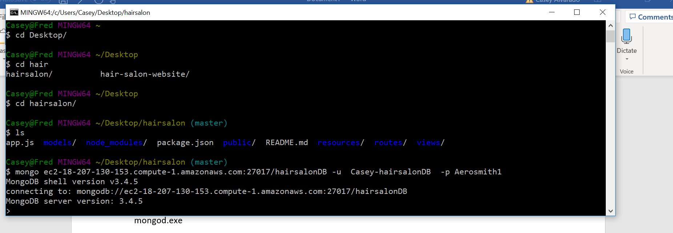

Then type

use hairsalonDB

show collections

This should show the clients collection

Then do db.clients.find().pretty() and all of the customers should pop up

___________________________________________________________________________________

As for the controlling the actual app, then use putty with the ec2-whatever instance name and the pdk (see instructions in the scotch.io webpage) and log in as bitnami

Then go to apps > hairsalon

And here you can start and stop the app. Will happen later.

**Note: that the public dns name (the one that starts with ec2-xx) changed on me so maybe it changes every once in a while. It changed from**

**ec2-34-204-182-56.compute-1.amazonaws.com to**

**ec2-18-207-130-153.compute-1.amazonaws.com to**

**ec2-34-226-244-196.compute-1.amazonaws.com to**

**18.214.144.55**

**When this happens three things:**

1. Check Mongo to make sure data there and correct ec2-#

Follow the instructions to run mongodb on your own shell.

1. Need to change the uri in app.js

In Desktop/hairsalon/app.js, change the uri like so:

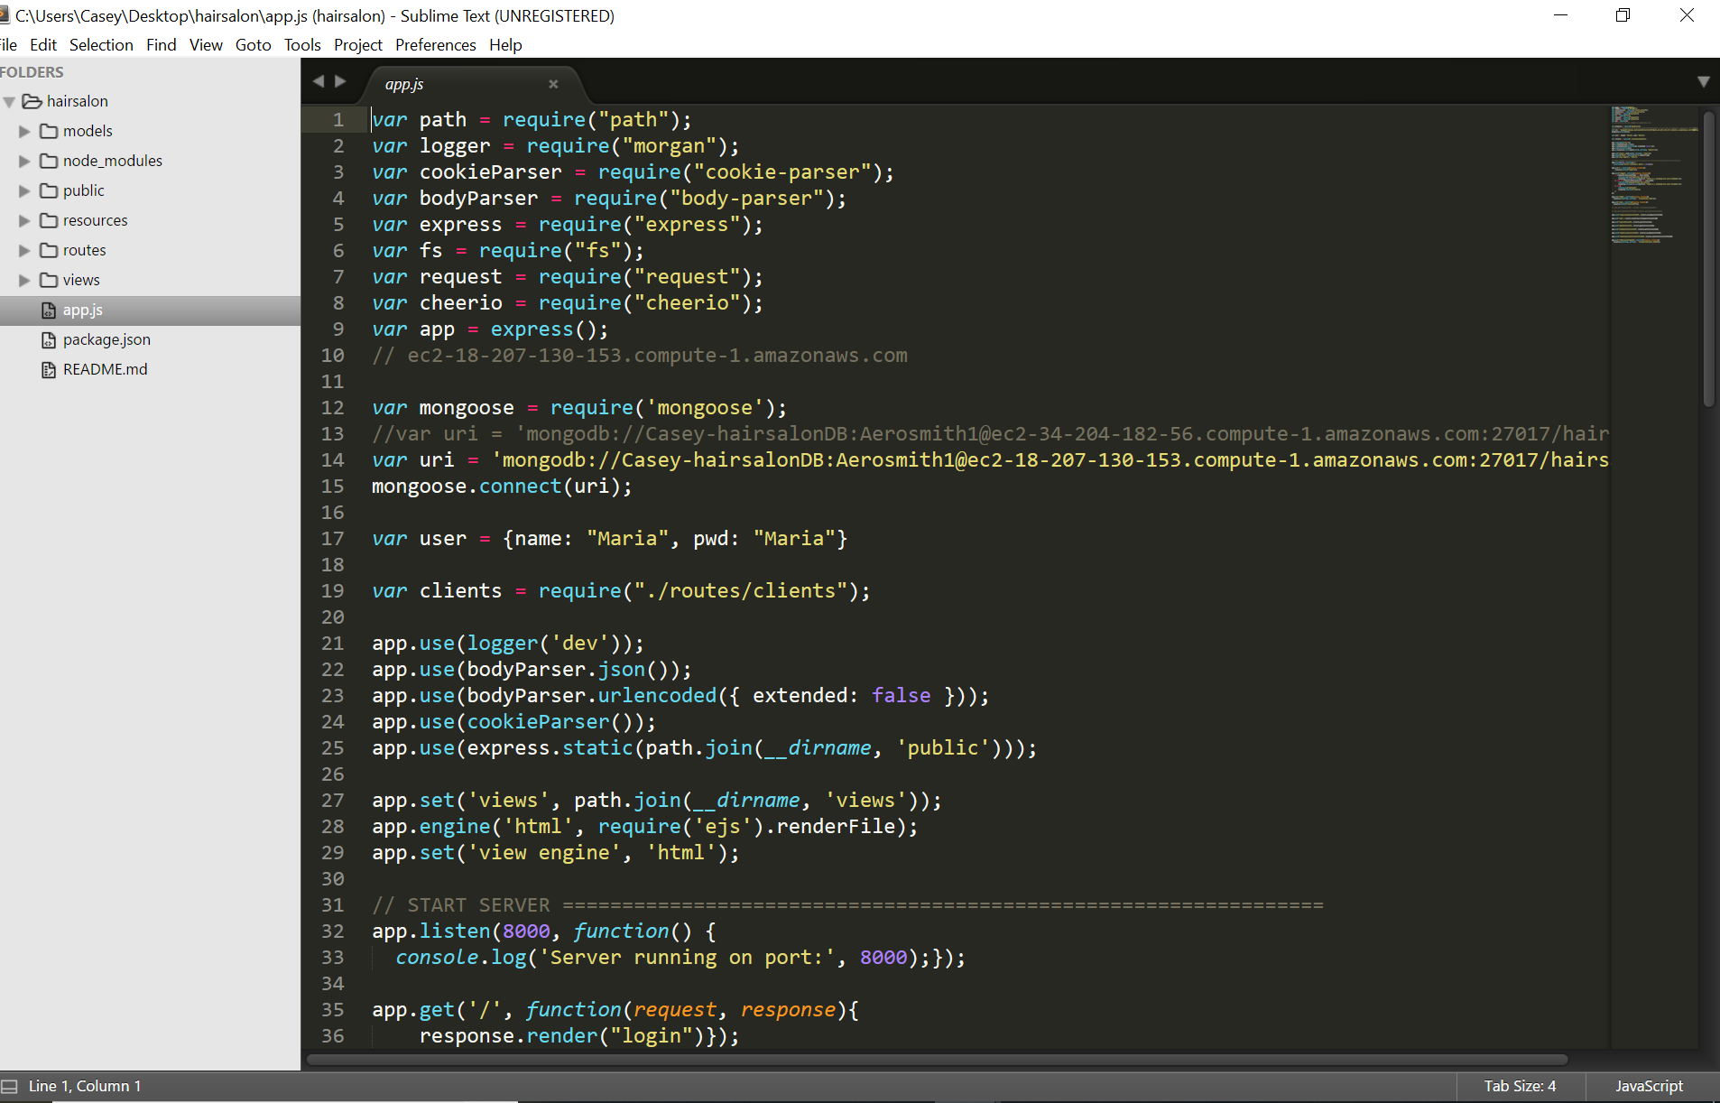

1. Then back to GitBash, exit from mongo, commit and push changes on Gitbash in this folder.

Ctrl-C

Git status

Git Add -A

Git commit -am “”

Git Push Origin

1. Open Putty. use putty with the ec2-whatever instance name and the pdk (see instructions in the scotch.io webpage) and log in as bitnami.

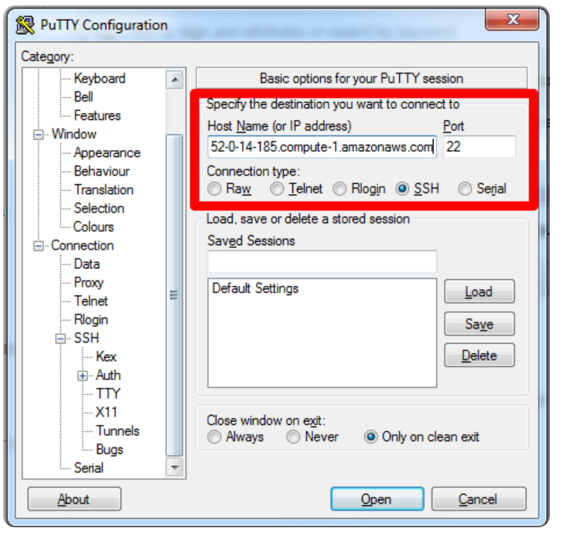

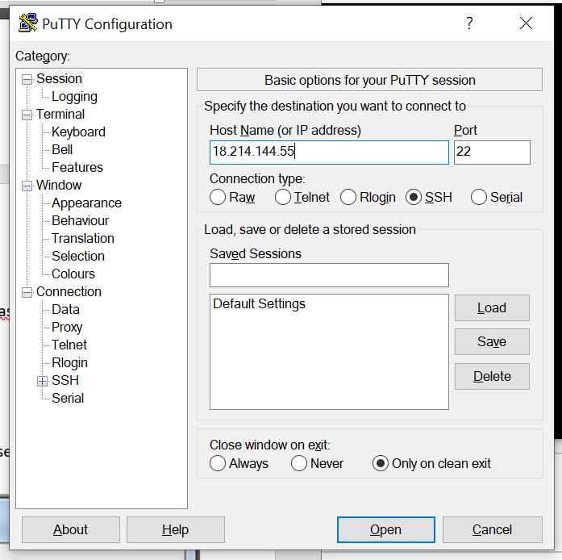

Then go to SSH 🡪 AUTH and in Private Key Authentication, Browse to Desktop/hairsalon/hairdesiresalonfiles.ppk

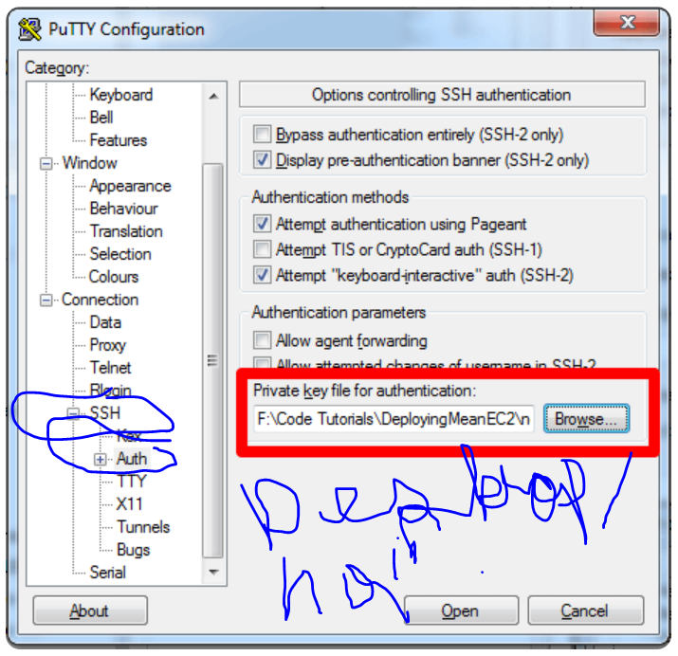

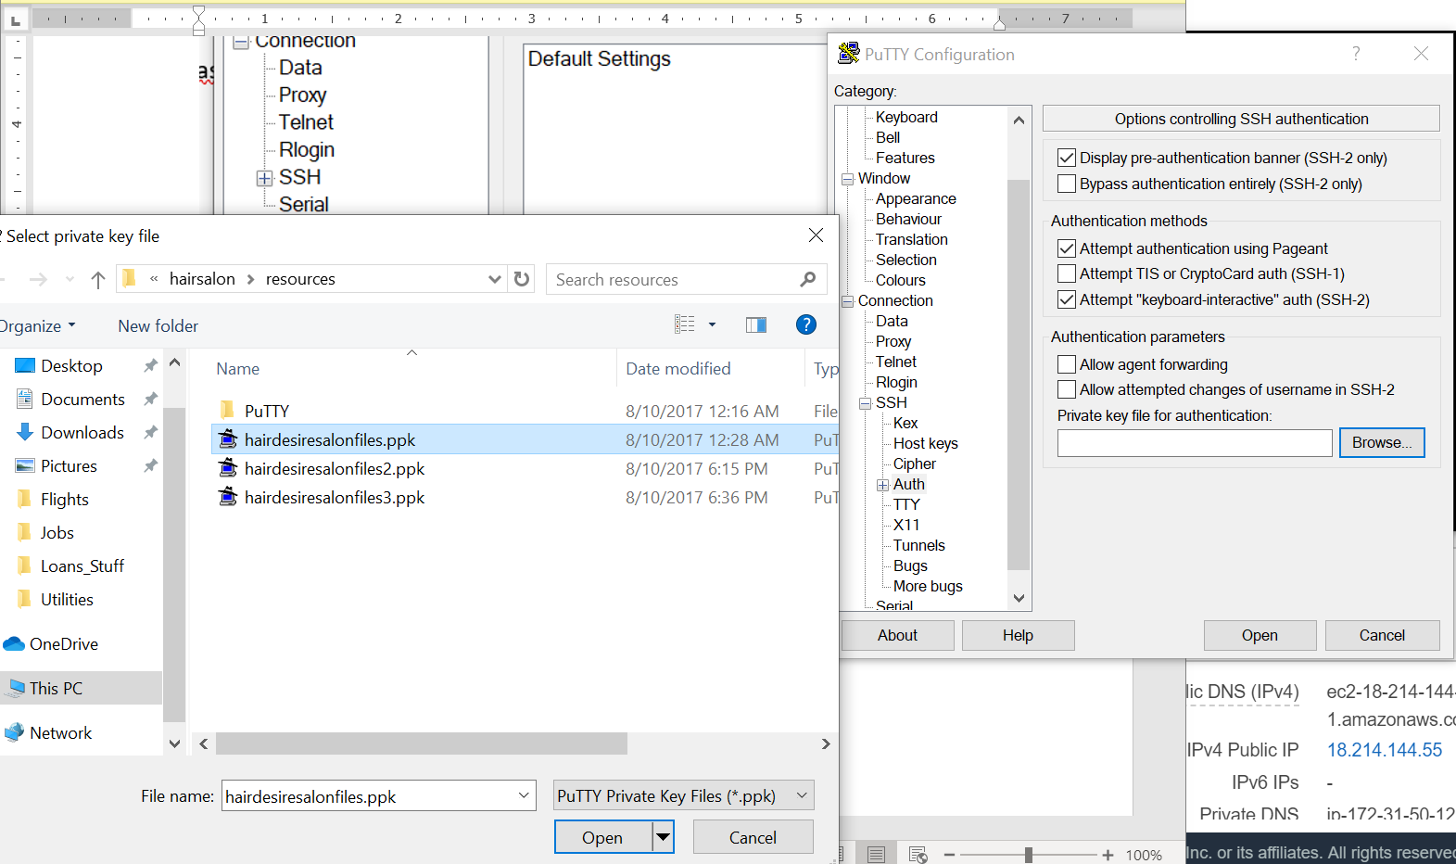

Log in as bitnami

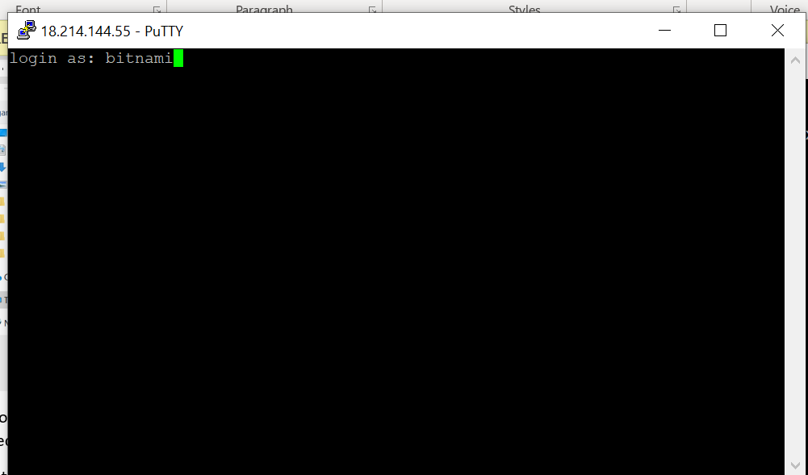

Then go to putty, navigate (cd) to apps/hairsalon and then do sudo git pull. Should pull from the repo I just Pushed to. Should see it say that it downloaded changes.

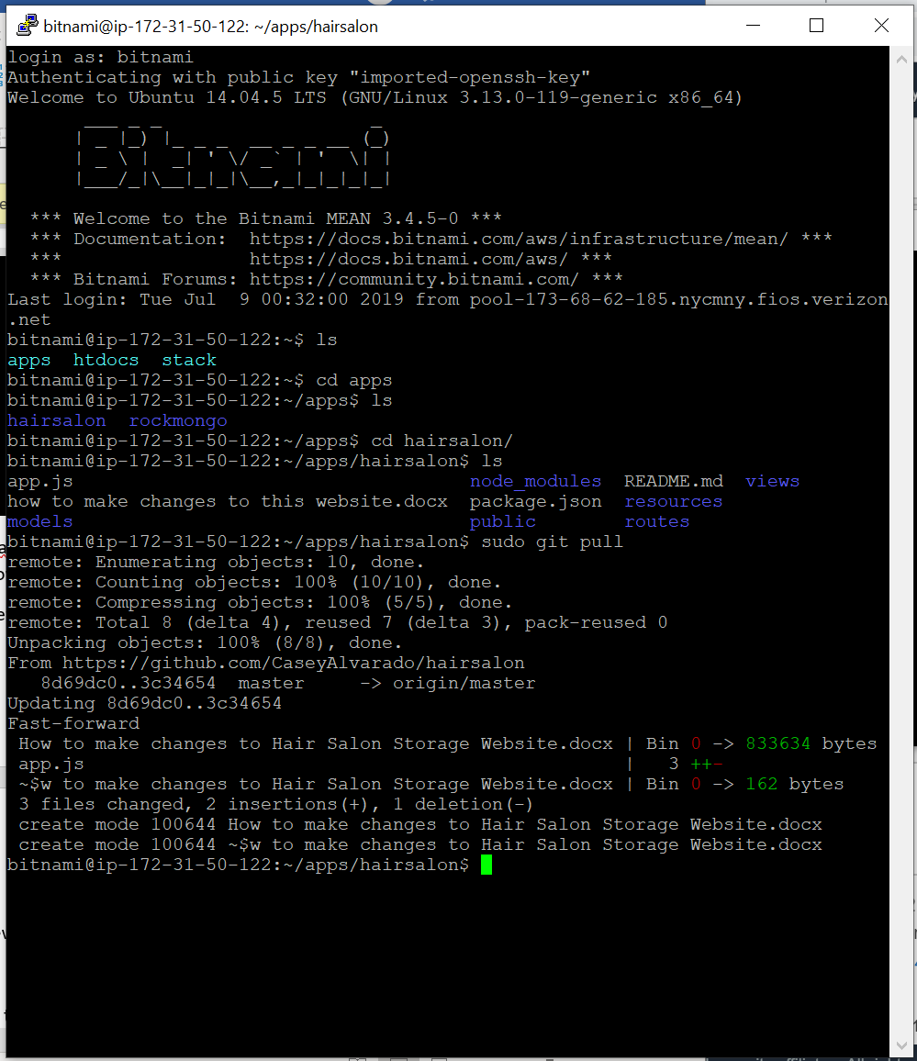

Then want to do forever stopall (to get new changes)

And then forever start app.js (to make new changes go in effect)

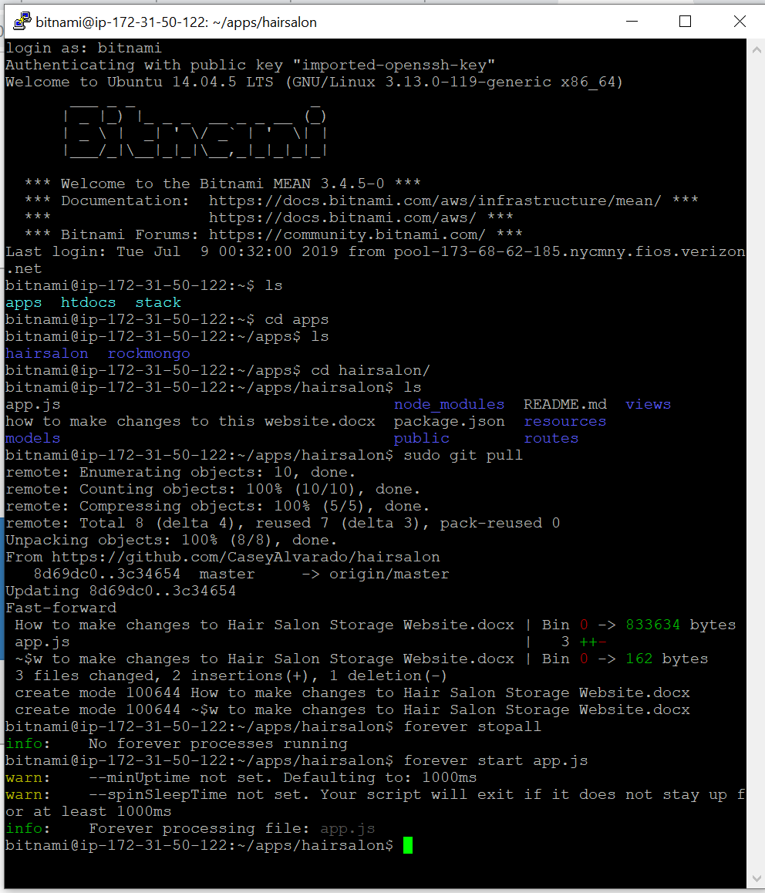

1. Public dns changes

Since public dns name changed. Now to access the website online is the new public name. Previously was

WEBSITE URL: <http://ec2-34-204-182-56.compute-1.amazonaws.com:8000/home>

NEW WEBSITE URL AS OF 12/14/2018 TO ACCESS IT ON THE INTERNET IS :

NEW WEBSITE URL AS OF 7/8/2019: <http://ec2-34-226-244-196.compute-1.amazonaws.com:8000/home>

NEW WEBSITR AS OF 7/9/2019: <http://18.214.144.55:8000/home>

for any confusion or whatever go through this tutorial: <https://scotch.io/tutorials/deploying-a-mean-app-to-amazon-ec2-part-1>

see part 2 of this tutorial: <https://scotch.io/tutorials/deploying-a-mean-app-to-amazon-ec2-part-2>

Github Credentials: CaseyAlvarado ///pw Aerosmith1